Personalized Health Monitoring Assistance

**Wordh Ul Hasan, Mohammad Sultan Khaja, Saif Ahmed & Mohammad Monirujjaman Khan (Mentor)***Department of Electrical & Computer Engineering,  
North South University*[wordh.u.hasan@ieee.org](mailto:wordh.u.hasan@ieee.org), [mohammads.k.92@gmail.com](mailto:mohammads.k.92@gmail.com), [saif.ahmed20@northsouth.edu](mailto:saif.ahmed20@northsouth.edu)

***Abstract***—In recent times, treatment of patients of chronic diseases has been a matter of great concern. In this project, we have tried to tackle the problems associated with chronic diseases, especially the ones that come with old age and sustain for a long period of time. The project subjects to the difficulty in keeping a patient admitted to a hospital for a long period of time and gives a 24 hour assistance to the patient at home. The project monitors the basic determinants of health of a patient including BPM, Blood Pressure, Temperature, Blood Glucose level, Breathing Rate and Cardiac Arrhythmia. The samples of photoplethysmogram (PPG) and electrocardiogram (ECG) signals along with temperature are processed to determine irregularities concerned to the health condition of the patient and store the data to a web server every minute. Close relatives and doctors have access to the server through an android application which sends an alarm to either the patient’s close relatives or the doctor or both based on the severity of the irregularity. There is a switch which enables the patient to send an alarm to his relatives manually in case of any discomfort.

***Acknowledgement***—We would like to express our special thanks of gratitude to my teacher Mohammad Monirujjaman Khan as well as our Department, Electrical and Computer Engineering of North South University who gave us the golden opportunity to do this wonderful project on the topic Personalized Health Monitoring Assistance, which also helped us in doing a lot of research and we came to know about so many new things we are really thankful to them.

***1. Introduction***— During the recent decade, rapid advancements in healthcare services and low cost wireless communication have greatly assisted in coping with the problem of fewer medical facilities. The integration of mobile communications with wearable sensors has facilitated the shift of healthcare services from clinic-centric to patient-centric.

The current study addresses the issue of integrating a wearable sensor with mobile technology by developing a remote monitoring system for heart patients. In this study, we propose a real-time monitoring system comprising a wearable sensor, mobile application, and a web interface to overcome some of the issues. The wearable sensor has been used to generate patient’s diagnostic information which is then transferred to a smartphone wirelessly via Bluetooth low energy technology. Further, the collected information on the smartphone is transferred to a web interface via Wi-Fi/3G. The proposed system has the ability to generate emergency alerts on the basis of predefined values by comparing patient’s data to inform the doctor if there is a requirement of checkup or investigation. Providing most accurate results close to the conventional systems. The developed system has been evaluated under the supervision of the experts. The Patient condition can be monitored by nearby relatives or someone who is taking care of the patient. The patient has a manual button by which he/she can notify the person who is taking care of the patient if patient needs any assistance.

We have built the web interface using laravel framework. Laravel is a free open-source PHP web framework. This was intended for the development of web applications following the model-view-controller architectural pattern. Some of the features of laravel is modular packaging system with a dedicated dependency manager, different ways for accessing relational databases, utilities that aid in application deployment and maintenance. Laravel is regarded one of the most popular PHP frameworks. The Source Code of laravel is hosted in Github and licensed under the terms of MIT License.

Android Studio is the official integrated development environment (IDE) for Google's Android operating system, built on JetBrains' IntelliJ IDEA software and designed specifically for Android development. It is a replacement for the Eclipse Android Development Tools (ADT) as primary IDE for native Android application development. Android studio has been used for the development of the mobile app that we are using in our project.

Bluetooth is a wireless technology standard for exchanging data over short distances it uses short-wavelength UHF radio waves in the ISM band from 2.4 to 2.485 GHz from fixed and mobile devices, and building personal area networks (PANs). Bluetooth is used to transmit the data from the sensors modules to the android app.

For the Patient monitoring module we are using Multi Parameter Module Digital Spo2 OEM Module PM 6750 Patient Monitor System which was developed by Shanghai Berry Electronics. This is Bluetooth patient monitor OEM module. This includes six parameters ECG, NIBP, Spo2, RESP, Temp and PR. This module can be used with windows, android, linux etc but we are using with android only for our project. We have got the sdk by the company to develop our own system using their communication protocol. The module is suitable for both adult and child.

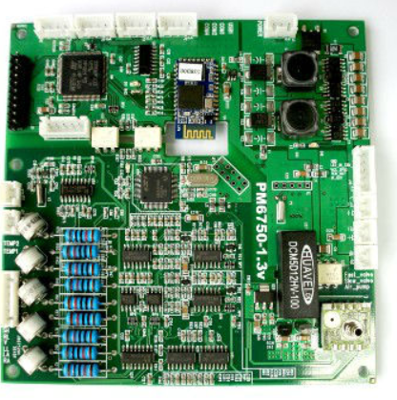

Fig 1: PM 6750 Module

The values we are getting ECG is one of them. An electrocardiogram (ECG) is a test which measures the electrical activity of your heart to show whether or not it is working normally. An ECG records the heart’s rhythm and activity on a moving strip of paper or a line on a screen. Usually a doctor can read and interpret the peaks and dips on paper or screen to see if there is any abnormal or unusual activity. ECG can detect cholesterol clogging up heart’s blood supply. A heart attack In the past, enlargement of one side of the heart and abnormal heart rhythms.

NIBP stands for Non-Invasive Blood Pressure. NIBP can monitor systolic, diastolic, mean blood pressure, as well as heart rate The NIBP consistently tracks the changes of systolic, diastolic, and mean blood pressure measured non-invasively and utilizes two separate cuffs

SpO2 stands for peripheral capillary oxygen saturation, an estimate of the amount of oxygen in the blood. More specifically, it is the percentage of oxygenated haemoglobin (haemoglobin containing oxygen) compared to the total amount of haemoglobin in the blood (oxygenated and non-oxygenated haemoglobin).

The respiratory rate is the rate at which breathing occurs. This is usually measured in breaths per minute and is set, and controlled by the respiratory centre. The typical respiratory rate for a healthy adult at rest is 12–18 breaths per minute. The respiratory center sets the quiet respiratory rhythm at around two seconds for an inhalation and three seconds exhalation. This gives the lower of the average rate at 12 breaths per minute. The value of respiratory rate as an indicator of potential respiratory dysfunction has been investigated but findings suggest it is of limited value.

Normal body temperature varies by person, age, activity, and time of day. The average normal body temperature is generally accepted as 98.6°F (37°C). Some studies have shown that the "normal" body temperature can have a wide range, from 97°F (36.1°C) to 99°F (37.2°C)

In electrocardiography, the PR interval is the period, measured in milliseconds, that extends from the beginning of the P wave (the onset of atrial depolarization) until the beginning of the QRS complex (the onset of ventricular depolarization); it is normally between 120 and 200ms in duration. The first measurement is known as the "P-R interval" and is measured from the beginning of the upslope of the P wave to the beginning of the QRS wave. This measurement should be 0.12-0.20 seconds, or 3-5 small squares in duration.

***2. Methods***— This study develops a remote monitoring diagnostic framework to detect underlying heart conditions in real-time which helps avoiding potential heart diseases and rehabilitation of the patients recovering from cardiac diseases. The proposed real-time monitoring system is compatible to use various sensors to extract medical information which helps finding out multiple parameters such as heart rate, blood pressure, and body and skin temperature at the same time. These cardiac parameters help early detection of diseases such as arrhythmia, hypotension, hypertension, and hyperthermia through alarming system based on upper and lower threshold values. Similar to the existing monitoring systems, the developed system has two interfaces, one for patients and other for the doctor. The patient interface is comprised of wearable sensors which extract medical information of the patients and transmit to an Android based listening port via Bluetooth low energy. The listening port transfers this information to web server which processes data to show reports on doctor interface. The details of the system architecture, components, data processing, and alarming system are explained as follows.

***2.1 System Architecture***— The system consists of three entity. The patient, The assistance who looks after the patient and the doctor. The Sensor Module is connected with the patient and taking different values using the sensors to the device. The device is wirelessly transmitting the data to the patient’s android app using Bluetooth communication medium. The Bluetooth is uploading the data in the web server. The Assistive person of the patient and the doctor can view the condition of the patient from web portal or android app from remote locations.

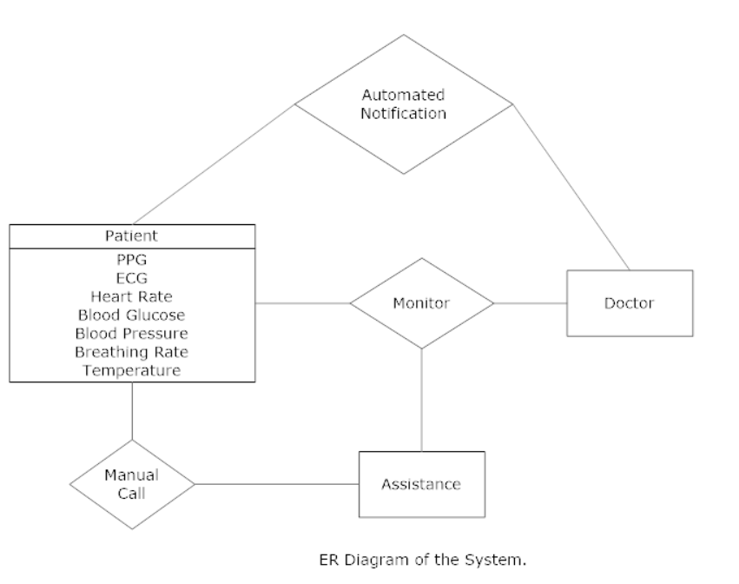

Fig 2: ER Diagram

The ER Diagram shows Patient has PPG, ECG, Heart Rate, Blood Glucose, Blood Pressure, Breathing Rate and Temperature as attributes which are taken from the sensors and these can be monitored by the doctor and the assistive person. Patient can also manually call for help to the assistive person. Doctor and Assistive person will receive a notification when abnormal reading is taken from the patient.

***2.2 System Communication***— The system will have 3 kinds of users. The main and prior users are patients which are connected with the sensors. The sensors will send data over Bluetooth the android app and the android app will parse those data into a server and store them and analysis them.

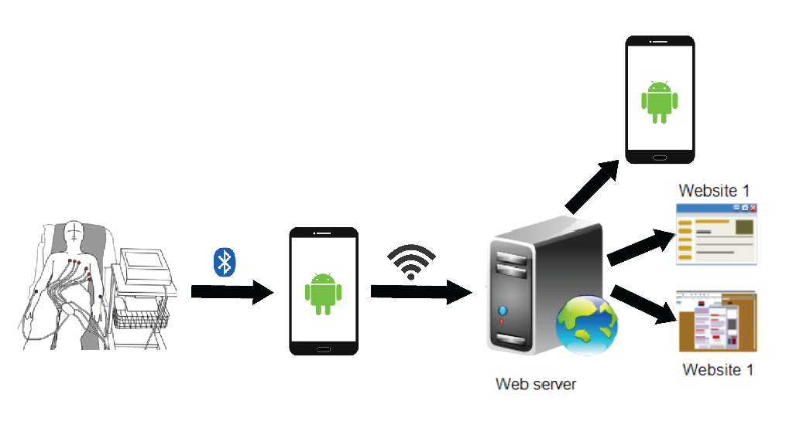

Fig: Communication System

The Stored data can be viewed real time by the assistive persons and the doctors. Based on the data doctors can give further instructions.

***2.3 hardware Implementation*** —

TBA ( To be completed in 499B )

***2.4 Android App***—

Details will be completed in 499B

TBA ( To be completed in 499B )

First phase design is completed and screenshot is attached.

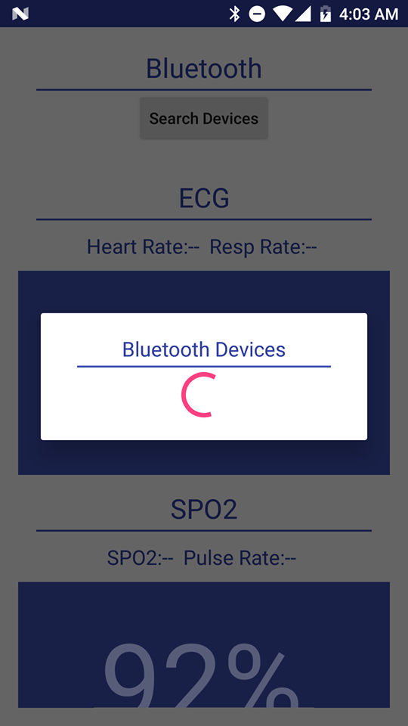 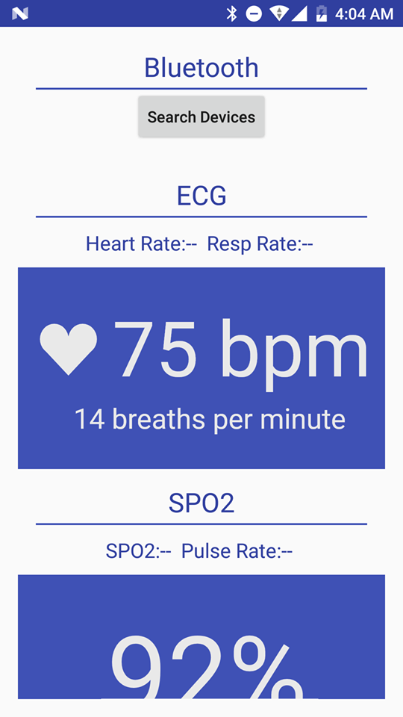

Fig: Connecting with Device Fig: Android App

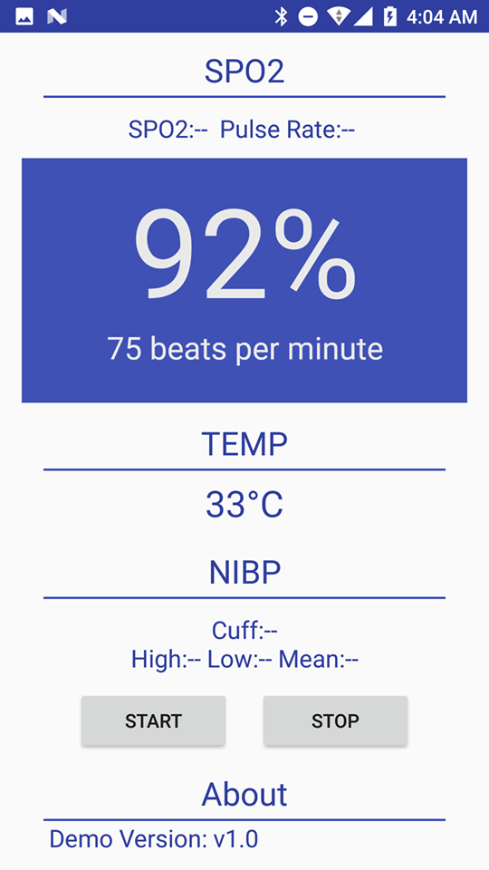

Fig: Showing data in the app.

In the android app after connecting with the device the data can be viewed in the manner shown in figure. For the time being the data has been showed are dummy. And we will be using real data once we get the device up and running. The android app has been developed using the SDK provided by the Berry Electronics.

In the flowchart we have shown the workflow of the android app.

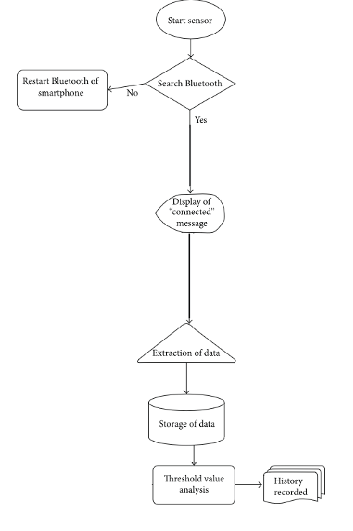

Fig: Flowchart of the System

***2.5 Web Interface***— Web interface enables several physicians, doctors, and medical centers to view and diagnose patients’ medical status simultaneously. However, to ensure data visibility only to authorized doctor/physician, web portal requires user ID and password. Web interface is implemented using Larval PHP framework. The data from the listening port is presented to the doctor on web portal in order to check medical status of the patient.

3. ***Results and Data***—

TBA ( To be completed in 499B )

4. ***Market Research and Analysis***—Currently available Devices are very expensive in the market and these devices are not available in Bangladesh. As we are aiming for a remote personalized assistive system which is very in need at this moment in this country as there are very less amount of doctors in many remote areas or rural hospitals. These system can help those areas greatly and Doctors can work remotely taking better care for many patients who are in need.

5. ***Conclusion***— Increasing rate of chronic diseases in aging population is becoming a serious concern due to lack of sufficient facilities and extremely high cost. The situation is even worse for the people residing in remote areas far from medical facilities as delay in diagnosis and treatment may lead to death. Timely diagnosis and treatment can solve these issues to a great extent. The advancements in wireless communications and wearable sensor technology open up the opportunity of real-time healthcare monitoring systems. In this study a real-time heart monitoring system for heart patients located in remote areas has been proposed. The developed system is comprised of wearable sensors, Android handheld device, and web interface. The system is adaptable and has the ability to extract several cardiac parameters such as heart rate, blood pressure, and temperature of multiple patients simultaneously. The extracted data is being transmitted to Android handheld device using Bluetooth low energy which is then transmitted to web application for further processing. Web application processes received data to show medical status of the patient along with personal information such as age, gender, address, and location on web interface. An alarming system based on threshold values has also been designed which sends alert message to the doctor in case of abnormalities such as arrhythmia, hypotension, hypertension, fever, and hypothermia.